PrinLab PTC Thermistor Measurements

Santtu Nyman

# Printed PTC Thermistor

In the Cold Water Dispenser printed electronics project a printed temperature sensor from PrinLab is used to measure temperature of a water tank. The printed temperature sensor is PTC thermistor with large resistance. The PTC is used in a voltage divider and the voltage from it is measured using 12 bit ADC. Linear calibration is used to calculate temperature from resistance. From test measurements done in the beginning of the project we able to tell that the change in resistance from change in temperature is linear in range of 0 °C to 40 °C and stops being linear after 40 °C. Actual temperature measurement is done directly from the ADC output value skipping unnecessary calculations using voltage or resistance.

# Issue with calibration

Some weeks after initial calibration of the voltage divider with the PTC was done when, trying to do test measurements the measured values had error of about ~50 °C and resistance of the PTC had increased. It was unknown why this had happened. It was not known how the sensor can be used reliably, so it needed to be investigated. Possible causes for the change in resistance were damage from bending, oxidation of the ink, damage from moisture, chemical changes of the ink or some combination.

# Measurements

It was decided that resistance of the PTC needed to be measured over time and it’s resistance to be compared to other PTC from the same batch. Many other PrinLab PTC from same batch were measure and compared to the sensor used in this project and all other PTCs had resistance in range of 1.1 MΩ to 2.4 MΩ but our PTC had resistance of 3.5 MΩ and after the PTC was installed to the water tank it’s resistance increased again. PTC resistance measurements over time revealed that it does not seem to be changing over time. The measurements of resistance over time were done in ~6 °C and ~23 °C once per day and temperature was measured using Dallas S18B20 digital temperature sensor.

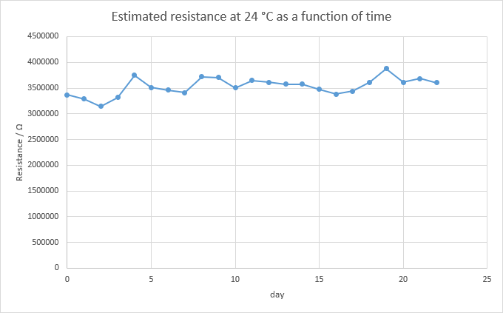

IMAGE 1 daily resistance measurements.

The resistance at 24 °C is estimated from two other measurements because, it was impractical to get measurements from exactly same temperature every day. The estimated daily resistance from measurements is in image 1. From this it seems likely that the PTC has damaged from being bend and the PTC’s resistance does not change over time.

# Summary

When working with printed components you are required to be careful not to damage the printed components by bending or otherwise. Causing damage to the ink of the components is very easy. Protecting the printed components by putting them inside some case or inside protective material might be good idea.